South East Queensland households urged to check hot water setup before switching to new Solar Sharer Offer
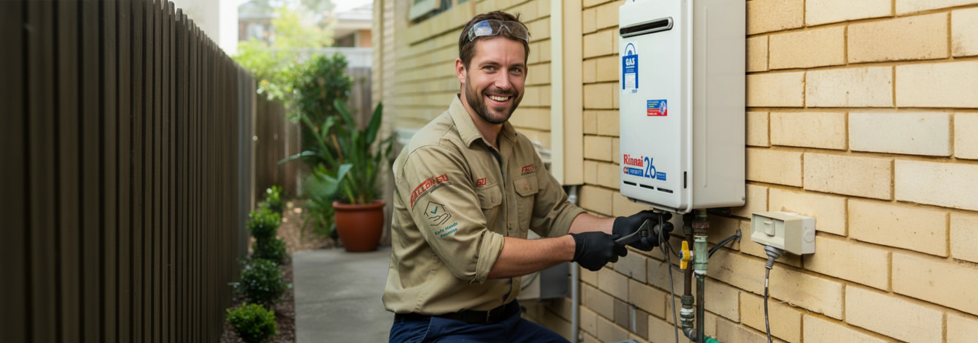

Brisbane, QLD — July 2026

Fallon Solutions is urging eligible South East Queensland households to check their hot water setup before making changes under the new Solar Sharer Offer, which started on 1st July 2026 and includes three hours of free daytime electricity between 11am and 2pm for eligible customers with smart meters. The Australian Energy Regulator (AER) has set the Solar Sharer Offer as a new opt-in standing-offer type, with the free period fixed at 11am–2pm in South East Queensland and a daily reasonable use cap of 24 kWh.

The offer is designed to encourage households to shift more electricity use into the middle of the day, when solar generation is abundant, instead of adding more demand to the evening peak. The AER has said the Solar Sharer Offer is intended to help customers take advantage of high daytime solar output and lower overall system costs.

Fallon Solutions General Manager electrical, Scott Sinclair, said that while some households may be able to move appliances such as washing machines, dishwashers, pool pumps, EV charging and electric hot water heating into the free usage window, homeowners should not simply switch hot water systems off and hope for the best. Hot water is one of the areas where households needed to be especially careful.

“On the surface, the Solar Sharer Offer sounds simple, and for some homes it may create a real opportunity to reduce daytime energy costs,” Mr Sinclair said. “But when it comes to hot water, you do not want to make changes blindly. Not every system is suitable, not every tariff is suitable, and not every household uses hot water in the same way.”

Mr Sinclair said electric storage hot water systems may, in some cases, be able to take advantage of a correctly

set timer, but the right approach depended on the home’s electrical setup, tariff structure and daily usage needs.

“Some systems are connected to controlled load tariffs, some households need more hot water than others, and storage tanks still need to heat correctly to maintain safe water temperatures,” he said. “If the setup is wrong, homeowners could end up with cold showers, safety concerns or bill surprises instead of savings.”

Customers can book one of Fallon Solution’s licensed electricians to assess whether their existing hot water system can be safely timed to better align with the 11am–2pm Solar Sharer window.

Fallon Solutions is also currently promoting a hot water timer fully installed from $499, including a 20-amp contactor switch with manual override.

Mr Sinclair said households should treat the new offer as an opportunity to ask smarter questions about how their home uses electricity. “This is not just about chasing three free hours in the middle of the day,” he said. “It is about making sure your hot water system, timer setup and electrical configuration are actually suited to the offer before you make a change. The right setup could help some households make better use of daytime electricity, but it needs to be done properly.”

He said South East Queensland homeowners should check their electricity plan, hot water system and household usage patterns before assuming the offer would automatically deliver savings.
“The best outcome is an informed one,” Mr Sinclair said. “If your household is a good fit, there may be a real benefit. But the key is understanding your setup first, rather than making assumptions.”

For customers wanting to learn more about the Solar Share Offer they can go to https://www.aer.gov.au/system/files/2026-05/AER%20-%20Solar%20Sharer%20Offer%20fact%20sheet%20-%20DMO%208%20final%20determination.pdf

For bookings or to learn more visit https://fallonsolutions.com.au or call 1300 873 105.

About Fallon Solutions
Fallon Solutions is one of Queensland’s largest and most trusted home service providers, offering electrical, plumbing, drainage, air conditioning, solar, and carpentry services for over 60 years. With more than 8,000 five-star reviews, a limited lifetime labour warranty, and a reputation built on reliability, Fallon keeps Queensland homes safe and comfortable all year round. We can be there today!

Media Contact:
Nicole Waters
Group Marketing Manager – Fallon Solutions
📞 1300 388 750
📧 nicole.waters@fallonsolutions.com.au

