Pre-summer air-conditioning service could save SEQ homeowners from a hot and costly mistake
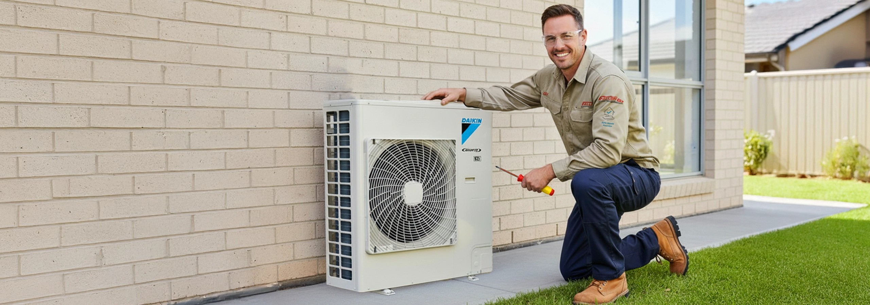

Brisbane, QLD — August 2026

South East Queensland homeowners are being encouraged to service their air conditioners before the first sustained hot weather arrives, with accumulated mould, bacteria, dust and grime potentially affecting airflow, cooling performance, indoor air quality and system efficiency.

Fallon Solutions General Manager Air Conditioning, Chris Ferris, said the end of winter was an ideal time to check both split-system and ducted air conditioners before demand increased, and technicians became busier during summer. “A lot of homeowners wait until their air conditioner smells, stops cooling properly or struggles through the first hot days,” Mr Ferris said. “By that stage, the system is already under pressure. Having it professionally serviced before summer can help improve airflow and cooling performance, support better indoor air quality and reduce unnecessary strain on the unit.”

Air conditioners operating in South East Queensland’s humid conditions can gradually accumulate contaminants inside components that cannot be reached through routine filter cleaning. Common warning signs include a musty smell when the system is switched on, weaker airflow, reduced cooling performance, visible dirt around the indoor unit or not having had the system professionally serviced within the past 12 months.

Mr Ferris said homeowners should understand the difference between cleaning a removable filter and having the internal system professionally serviced. “Washing the filters is worthwhile, but it does not remove all the mould, bacteria and grime that can build up deeper inside the unit,” he said. “A professional service should assess how the system is operating and clean the internal components that ordinary surface cleaning cannot reach.”

Fallon Solutions’ split-system servicing process includes checking system operation, recording performance readings, inspecting electrical terminals and components, and accessing the internal coil and blower for a deeper hygienic clean.

Fallon Solutions has also introduced Bronze, Silver and Gold service packs to give homeowners different levels of care depending on the condition of their system, their household requirements and their budget.

The service options can include performance recording, refrigerant pressure checks, supply and return temperature readings, motor running-amp measurements, electrical connection inspections, fan and component checks, anti-mould and antibacterial cleaning, and outdoor coil cleaning.
The Gold option also includes drain-pan flushing, condensate drain-flow testing, bio-slime treatment and air-sanitising gel designed to help reduce mould and bacterial regrowth.

“Not every air conditioner or household needs exactly the same service,” Mr Ferris said. “Some customers want a professional clean and performance check, while others need a more comprehensive treatment because of mould, drainage concerns, pets, allergies or heavier year-round use. “Our Bronze, Silver and Gold options allow us to recommend a level of service that suits the system, the home and the customer’s budget rather than applying a one-size-fits-all approach.”

For many homes, Mr Ferris recommends a professional deep clean every 12 months. Homes with pets, allergy concerns or air conditioners operating heavily throughout the year may benefit from servicing every six months.

Ducted systems also require attention, despite much of the equipment being out of sight. “A ducted system moves conditioned air throughout a large part of the home, so cleanliness and airflow have a major impact on overall comfort,” Mr Ferris said. “Having it checked before daily summer use begins can identify performance or cleanliness issues before the system is working at full capacity.”

The Bureau of Meteorology reported in late July that El Niño was continuing to strengthen, with its August-to-October outlook indicating drier conditions across parts of eastern Australia and an increased likelihood of above-average temperatures across much of the country.

Mr Ferris said early preparation could help homeowners avoid discovering a problem during the first major run of hot weather. “The best time to find out whether your air conditioner needs attention is before you are relying on it every day,” he said. “Booking early gives homeowners time to have the system cleaned, assessed or upgraded before the summer rush.”

Fallon Solutions is also offering homeowners the option to replace an older system with a 2.0 kW Daikin air conditioner from $2,933 fully installed, subject to site conditions and offer terms.

“With servicing and installation options available for different homes, needs and budgets, homeowners can make a planned decision now rather than being forced into an urgent one during a heatwave,” Mr Ferris said.

For bookings or to learn more visit https://fallonsolutions.com.au or call 1300 873 105.

About Fallon Solutions
Fallon Solutions is one of Queensland’s largest and most trusted home service providers, offering electrical, plumbing, drainage, air conditioning, solar, and carpentry services for over 60 years. With more than 8,000 five-star reviews, a limited lifetime labour warranty, and a reputation built on reliability, Fallon keeps Queensland homes safe and comfortable all year round. We can be there today!

Media Contact:
Nicole Waters
Group Marketing Manager – Fallon Solutions
📞 1300 388 750
📧 nicole.waters@fallonsolutions.com.au

